Lab 4
Shlomi Domnenko – 318643640

Lab Environment
Using deterlab as cloud virtual machines:
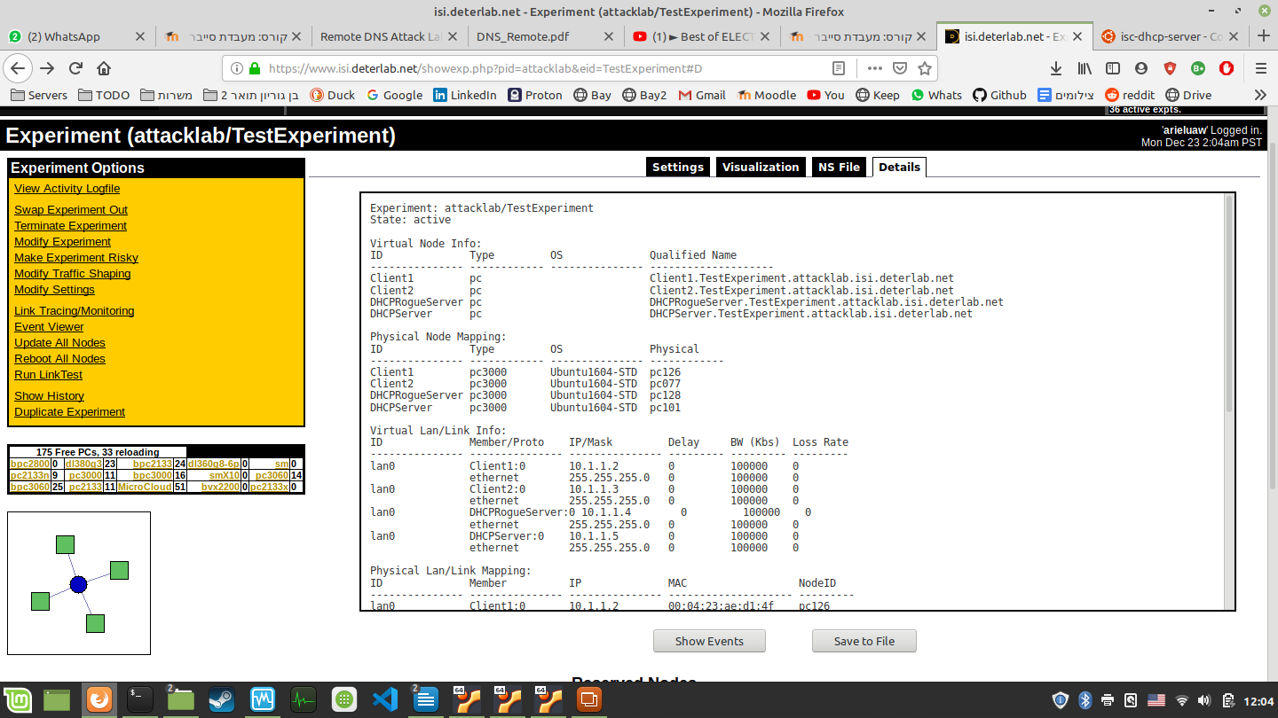
Addresses:
Client1.TestExperiment.attacklab.isi.deterlab.net
Client2.TestExperiment.attacklab.isi.deterlab.net
DHCPRogueServer.TestExperiment.attacklab.isi.deterlab.net
DHCPServer.TestExperiment.attacklab.isi.deterlab.net

NS File:

# Generated by NetlabClient

set ns [new Simulator]
source tb_compat.tcl

# Nodes
set Client1 [$ns node]
set Client2 [$ns node]
set DHCPRogueServer [$ns node]
set DHCPServer [$ns node]

# Lans
set lan0 [$ns make-lan "$Client1 $Client2 $DHCPRogueServer $DHCPServer" 100000kb 0ms]

$ns rtproto Static
$ns run

# NetlabClient generated file ends here.

# Finished at: Mon Dec 23 11:52:48 IST 2019

Lab Visualization

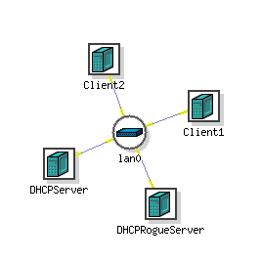
The middle node is a switch for the lan0 network

How to use the machines
- SSH into arieluaw@users.isi.deterlab.net
  - The password is: “Cyberlab19”
- Then, you can SSH into the machines, for example:
  - DHCPServer.TestExperiment.attacklab.isi.deterlab.net
  - The password is: “Cyberlab19”

Tasks
- SSH into DHCPServer, Create DHCP server (Download stuff)
- Test DHCP server by using client to get IP
- After the test is successful, create DHCP starvation attack
- Use the DHCPRogueServer to run the malicious script
- Test the attack by using diffirent client to get diffirent IP. The attack is successful when the client doesn’t get IP.

Setting up DHCP server

This is TMUX of the client1. On the left, we see tshark running inside client, and it shows DHCP discover, DHCP offer, DHCP request, DHCP ack:
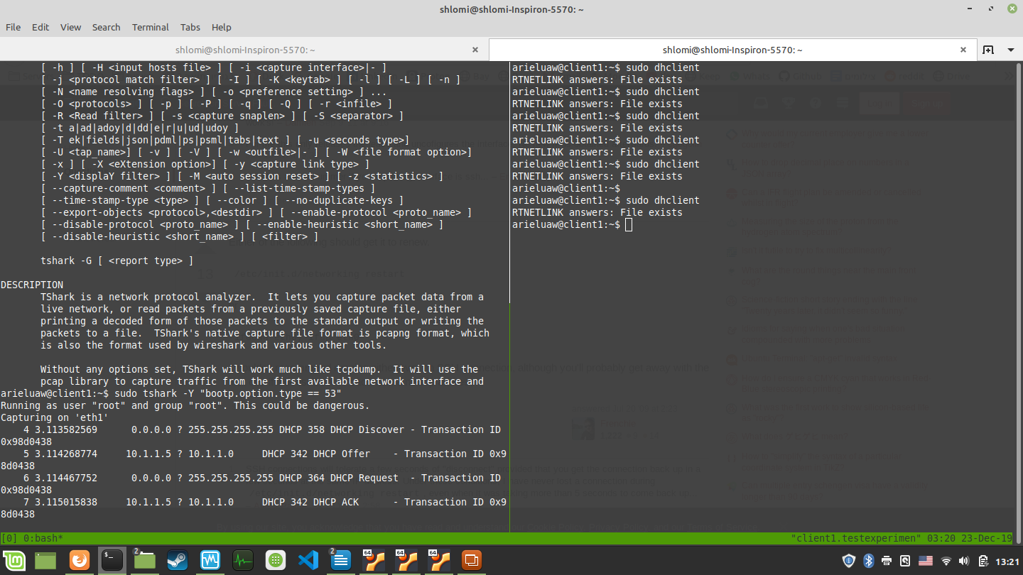

On the right, we use dhclient to renew our ip.

IP’s of other machines
